NAME:-SHAIK.Mofthiyar

REGISTERED NUMBER:-192110745

SUBJECT:-SOFTWARE ENGINEERING WITH AI TECHNIQUES

SUBJECTCODE:-CSA1OO1

FACULTY:-DR.G.MARY VALANTINA

EXPERIMENT:-05

DATE:-27-09-2022

AIM:-To draw USE-CASE diagram for ONLINE RAILWAY RESERVATION SYSTEM using umbrello

DIAGRAM:-

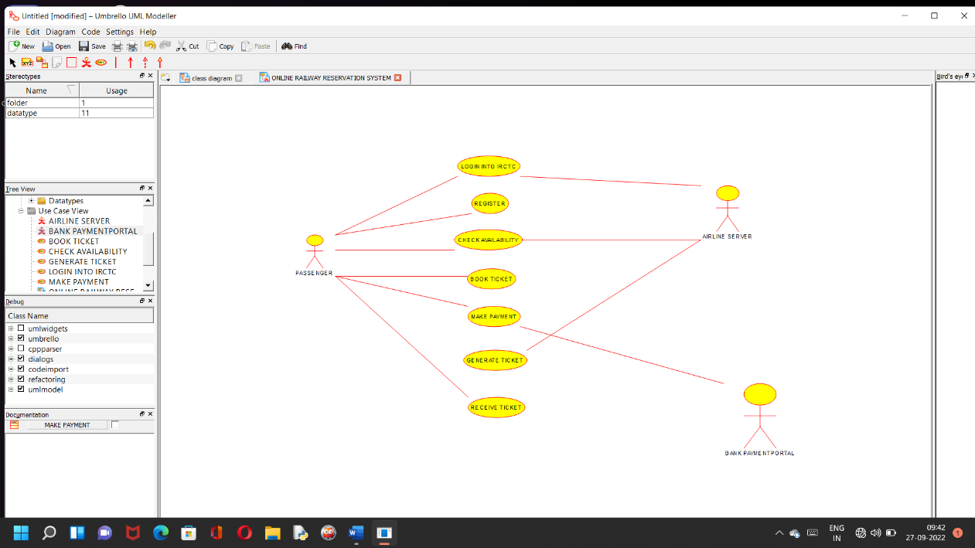

RESULT:-

SSuccessfully done the use case diagram of ONLINE RAILWAY RESERVATION SYSTEM in umbrello software

EXPERIMENT:-06

DATE:-27-09-2022

AIM:-To draw USE-CASE diagram for HOSPITAL MANAGEMENT SYSTEM using umbrello

DIAGRAM:-

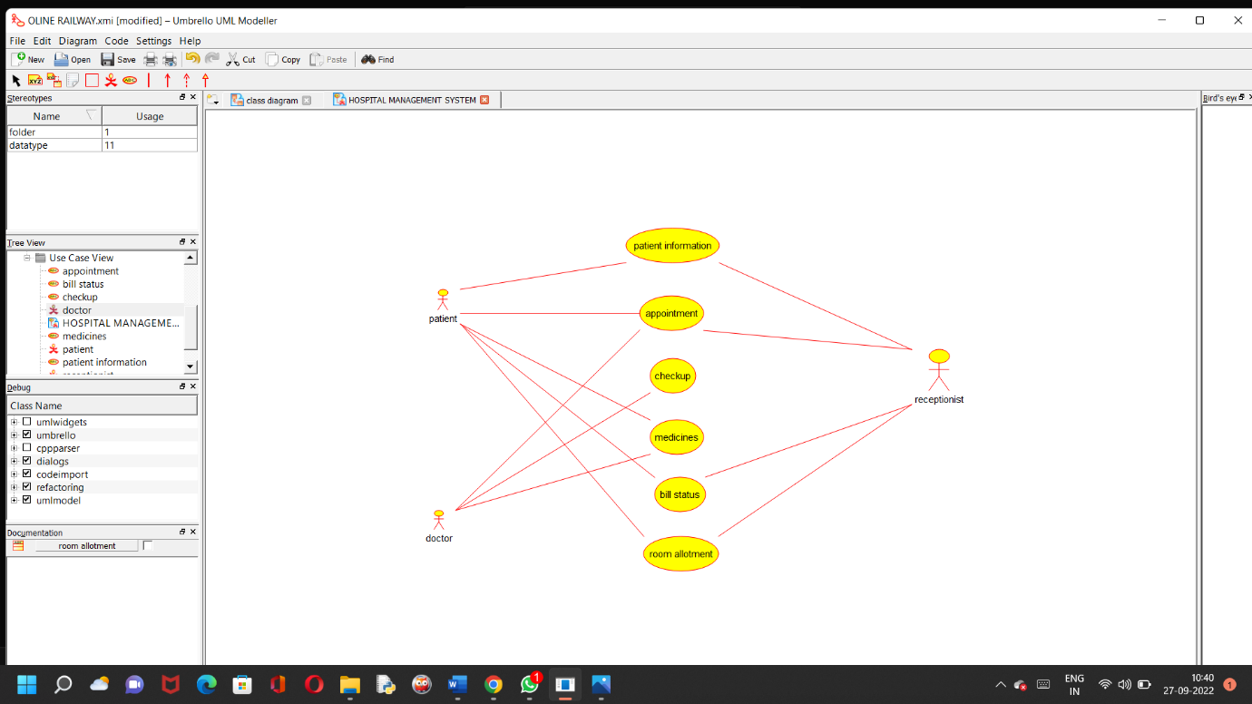

RESULT:-

SSuccessfully done the use case diagram of HOSPITAL MANAGEMENT SYSTEM in umbrello software

EXPERIMENT-07

DATE:-27-09-2022

AIM:- To draw USE-CASE diagram for ATM SYSTEM using umbrello

DIAGRAM:-

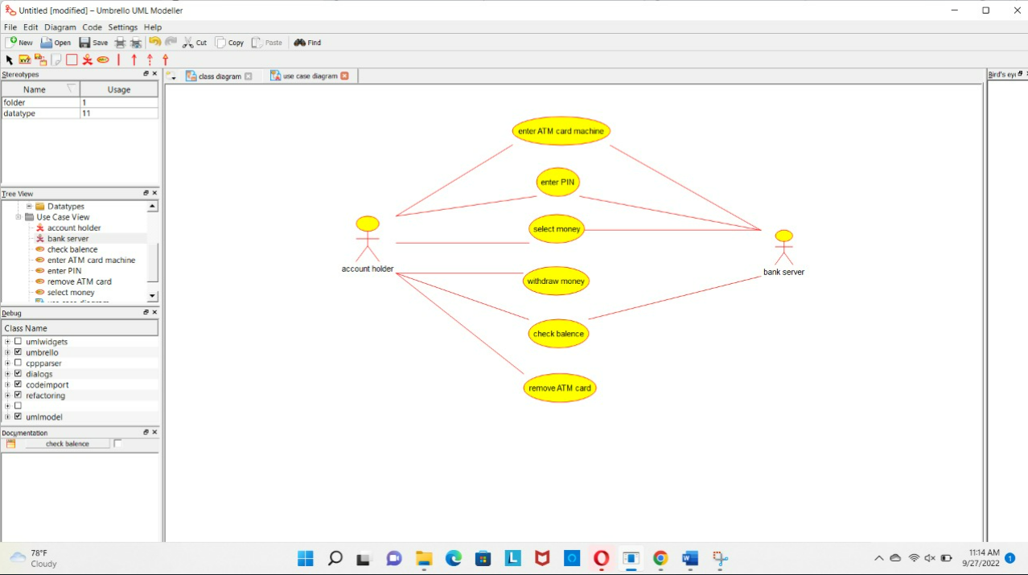

RESULT:- SSuccessfully done the use case diagram of ATM SYSTEM in umbrello software

EXPERIMENT-08

DATE:-27-09-2022

AIM:- To draw USE-CASE diagram for ONLINE SHOPPING SYSTEM using umbrello

DIAGRAM:-

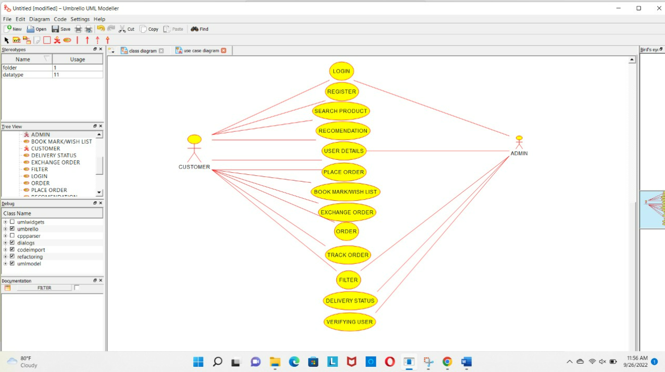

RESULT:-

SSuccessfully done the use case diagram of online shopping system in umbrello software.

EXPERIMENT-09

DATE:-27-09-2022

AIM:- To draw USE-CASE diagram for ONLINE AIRLINE RESERVATION SYSTEM using umbrello

DIAGRAM:-

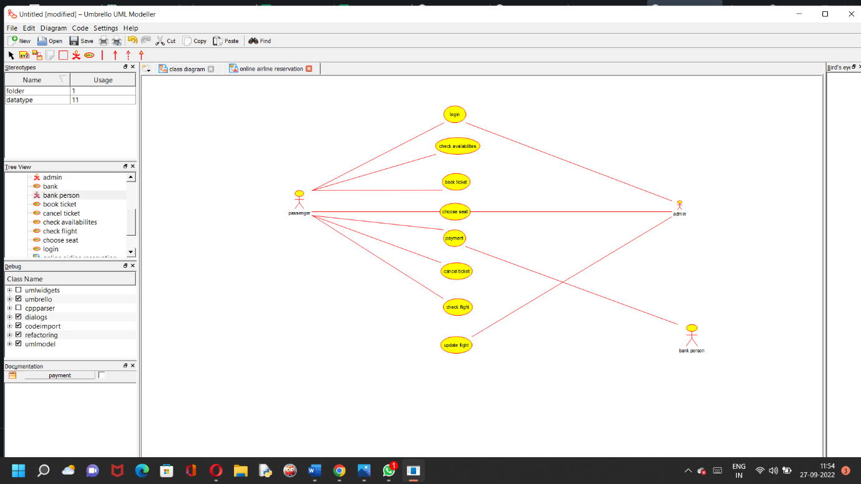

RESULT:- SSuccessfully done the use case diagram of ONLINE AIRLINE RESERVATION SYSTEM in umbrello software

S

EXPERIMENT-10

DATE:-27-09-2022

AIM:- To draw CLASS DIAGRAM diagram for ONLINE AIRLINE RESERVATION SYSTEM using umbrello

DIAGRAM:-

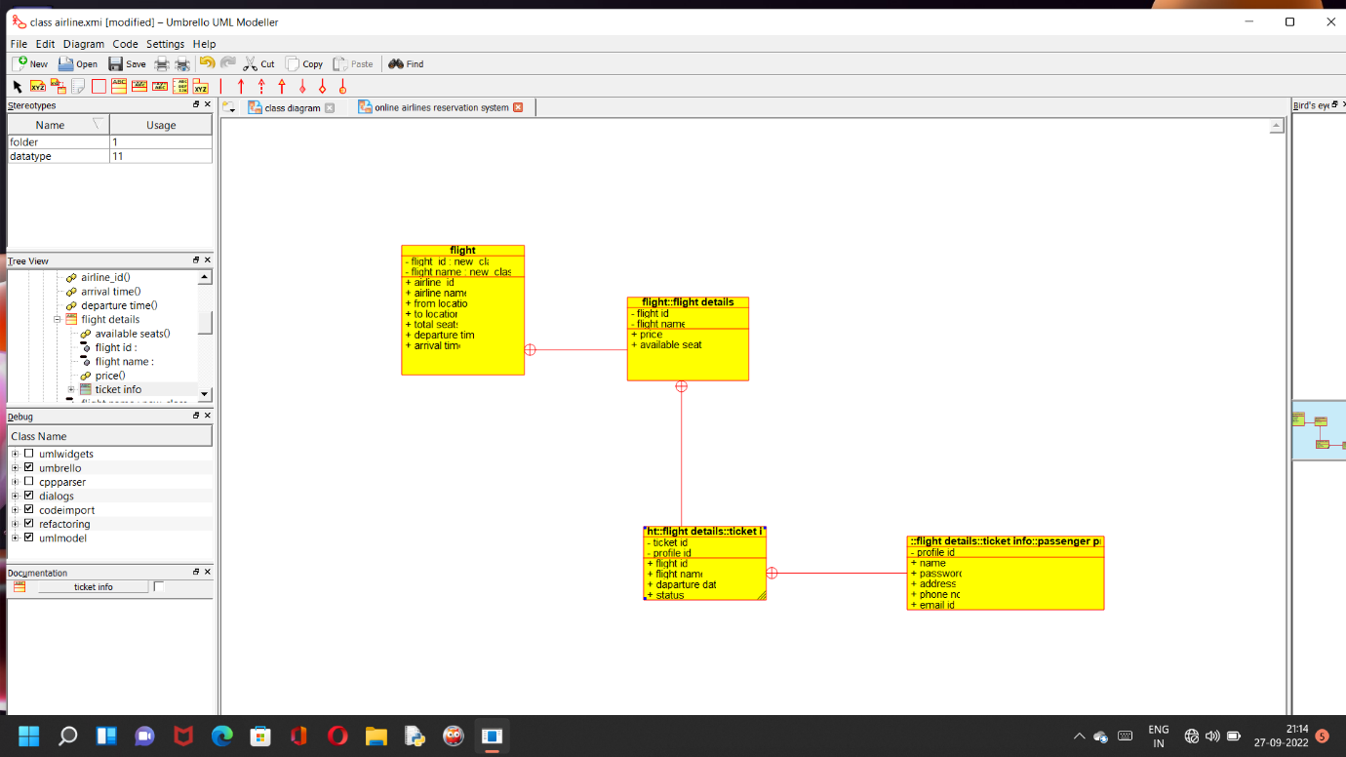

RESULT:- SSuccessfully done the CLASS DIAGRAM of ONLINE AIRLINE RESERVATION SYSTEM in umbrello software